Chapter-4

## **PC components**

## **1.0 Ports and slots**

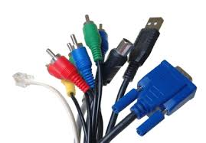 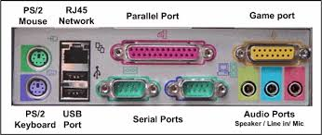

connectors

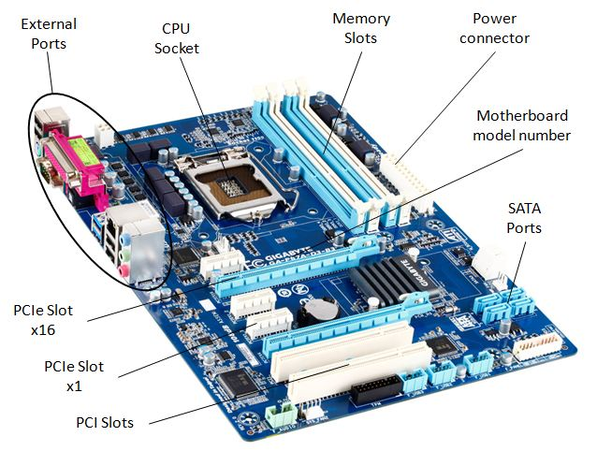

**Fig-1:Slots and ports on the motherboard**

## **2.0 LAN card**

Some cards, such as a PCMCIA card, can be used in a laptop. There are many other ways of connecting the LAN card to a computer. Some cards are connected via the USB port, some via the PCI port inside of the computer, and some are even embedded inside of the computer.

* A typical Ethernet cable, or network cable, is the plugin that goes into the LAN card, or the Network Interface Controller (NIC).
* Any type of network activity requires a LAN card: the Internet, network printer, connecting computers together, and so on

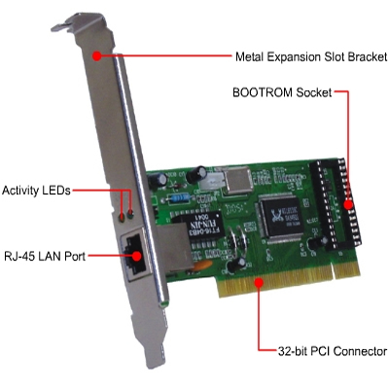

**Fig-2:LAN card**

## **3.0 Sound card**

* A sound card (also known as an audio card) is an internal expansion card that provides input and output of audio signals to and from a computer under control of computer programs. The term *sound card* is also applied to external audio interfaces used for professional audio applications.
* Sound cards use a digital-to-analog converter (DAC), which converts recorded or generated digital signal data into an analog format**.**

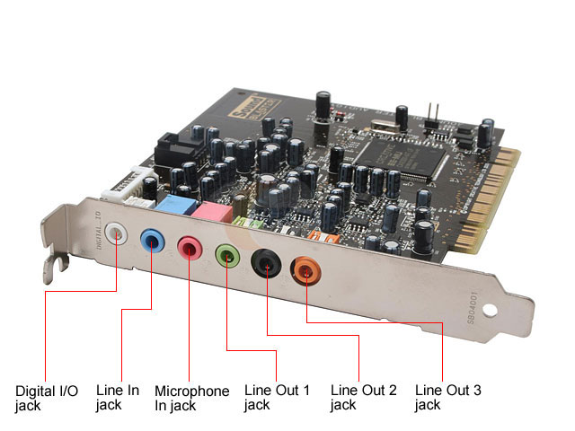

**Fig-3:Sound card**

## **4.0 Video card**

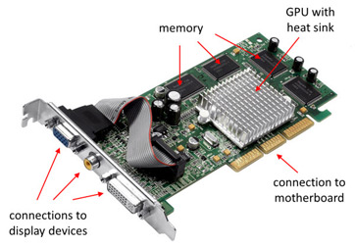

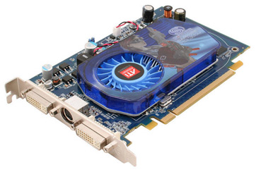

**Fig-4:video card**

* A **video card** connects to the motherboard of a computer system and generates output images to display. Video cards are also referred to as **graphics cards**. Video cards include a processing unit, memory, a cooling mechanism and connections to a display device.
* The processing unit on a video card is referred to as a **graphics processing unit (GPU)**. This is very similar to a CPU, but its design is optimized to work with images.
* The memory on a video card is very similar to the regular random-access memory (or RAM) on a motherboard.
* A video card connects to the motherboard of a computer system using a slot, typically an Accelerated Graphics Port (AGP) or a Peripheral Component Interconnect Express (PCIe) connection.

## **5.0 I/O cards**

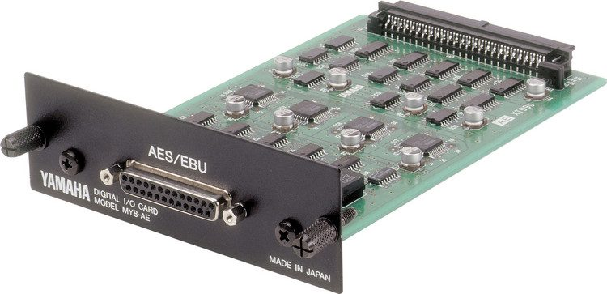

* In computing, **input/output** or **I/O**

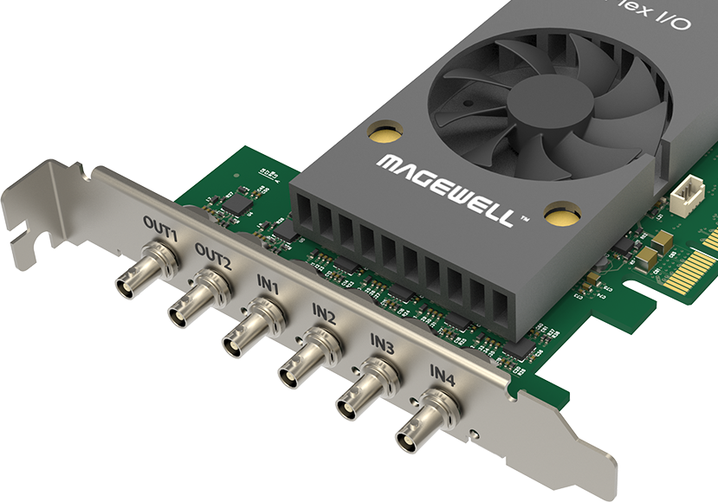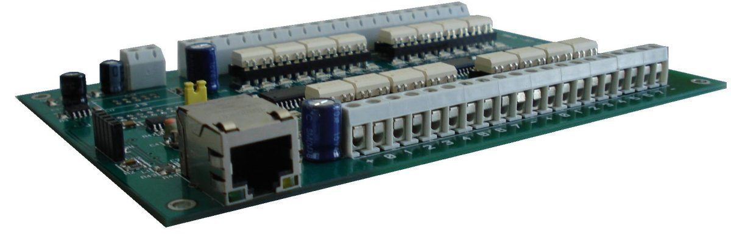

**Fig-5:I/o card**

I/O is the communication between an information processing system, such as a computer, and the outside world, possibly a human or another information processing system.

## **6.0 PCI Thunderbolt expansion card and USB card.**

Thunderbolt is the brand name of a [hardware interface](https://en.wikipedia.org/wiki/Interface_(computing)#Hardware_interfaces) developed by [Intel](https://en.wikipedia.org/wiki/Intel) (in collaboration with [Apple](https://en.wikipedia.org/wiki/Apple_Inc.)) that allows the connection of external [peripherals](https://en.wikipedia.org/wiki/Peripheral) to a [computer](https://en.wikipedia.org/wiki/Computer). Thunderbolt 1 and 2 use the same [connector](https://en.wikipedia.org/wiki/Electrical_connector) as [Mini DisplayPort](https://en.wikipedia.org/wiki/Mini_DisplayPort) (MDP), whereas Thunderbolt 3 re-uses the [USB-C](https://en.wikipedia.org/wiki/USB-C) connector from USB. It was initially developed and marketed under the name Light Peak, and first sold as part of a consumer product on 24 February 2011.[[1]](https://en.wikipedia.org/wiki/Thunderbolt_(interface)#cite_note-2011mbp-1)

Thunderbolt combines [PCI Express](https://en.wikipedia.org/wiki/PCI_Express) (PCIe) and [DisplayPort](https://en.wikipedia.org/wiki/DisplayPort) (DP) into two [serial](https://en.wikipedia.org/wiki/Serial_communication) signals,[[5]](https://en.wikipedia.org/wiki/Thunderbolt_(interface)#cite_note-5)[[6]](https://en.wikipedia.org/wiki/Thunderbolt_(interface)#cite_note-cunningham2015-6) and additionally provides [DC power](https://en.wikipedia.org/wiki/Direct_current), all in one cable. Up to six peripherals may be supported by one connector through various [topologies](https://en.wikipedia.org/wiki/Network_topology)

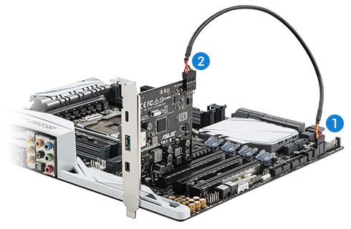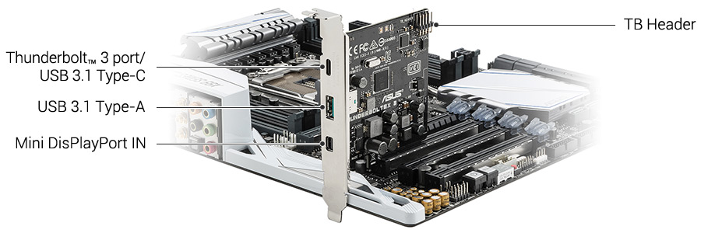

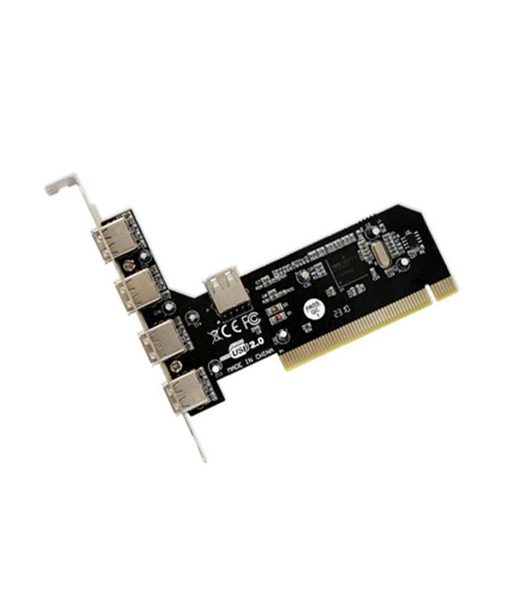

**Fig-6: PCI thunderbolt card**

## **7.0 VGA Cable**

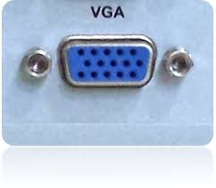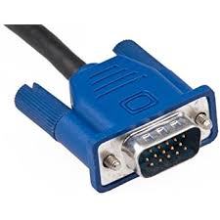

**Fig-7:VGA port and connector**

* Also known as D-sub cable, analog video cable
* Connect one end to: computer monitor, television (PC input port)
* VGA connectors and cables carry analog component RGBHV

(red, green, blue, horizontal sync, vertical sync) video signals.

## **8.0 DVI Cable Digital Visual Interface**

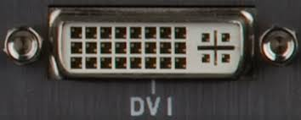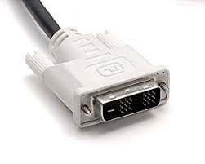

**Fig-8:DVI port and connector**

* there are 2 types of DVI, DVI-I and DVI-D
* DVI-D does not have the extra pins around the long pin, this is also a pure digital signal over DVI-I.
* The DVI connector on a device is given one of three names, depending on which signals it implements

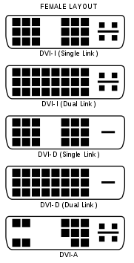

*DVI-I* (integrated, combines digital and analog in the same connector; digital may be single or dual link)

*DVI-D* (digital only, single link or dual link)

*DVI-A* (analog only)

## **9.0 HDMI**

* HDMI is a digital replacement for analog video standards.
* It is a proprietary audio/video interface for transmitting uncompressed video data and compressed or uncompressed digital audio data from an HDMI-compliant source device, such as a display controller, to a compatible computer monitor, video projector, digital television, or digital audio device.

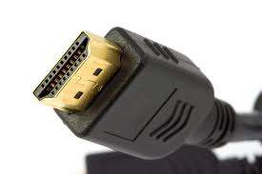 

## **10.0 PS/2 Cable**

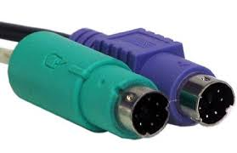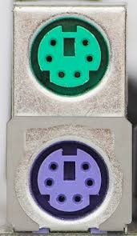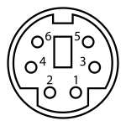 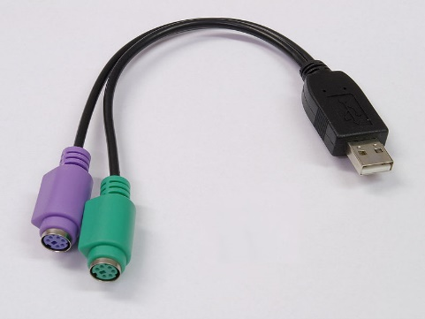

* **Purple PS/2 port: keyboard**
* **Green PS/2 port: mouse**

|  |  |  |
| --- | --- | --- |
| Pin 1 | +DATA | Data |
| Pin 2 |  | Not connected |
| Pin 3 | GND | Ground |
| Pin 4 | [Vcc](https://en.wikipedia.org/wiki/IC_power-supply_pin) | +5 V DC at 275 mA |
| Pin 5 | +CLK | [Clock](https://en.wikipedia.org/wiki/Clock_signal) |
| Pin 6 |  | Not connected |

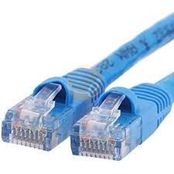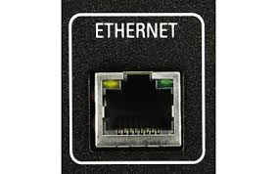

## **11.0 Ethernet Cable Also known as RJ-45 cable**

* An Ethernet cable is one of the most common forms of network cable used on wired networks. Ethernet cables connect devices within a local area network, like PCs, routers, and switches.
* Ethernet cables normally support one or more industry standards including Category 5 and Category 6. Most technicians refer to those standards as CAT5 and CAT6, respectively

## **12.0 Audio Cable** https://hardsoft-support.kayako.com/base/media/url/J2L1QdZve5X4ZlYkqsp4tL6qhgMYodx0

* A **phone connector**, also known as **phone jack**, **audio jack**, **headphone jack** or **jack plug**, is a family of electrical connectors typically used for analog audio signals.
* Green audio port: computer speakers or headphones
* Pink audio port: microphone
* Blue audio port: MP3 player, CD player, DVD player, turntable, electric guitar etc (line-in port to play and record sounds from the above devices)

## **13.0 What is multimedia?**

**Multimedia refers to any application that**

**combine text with other media elements.**

* + - * Graphics
      * Animation
      * Audio
      * Video
      * Virtual reality

## 13.1 What is the difference between dedicated graphics and shared graphics?

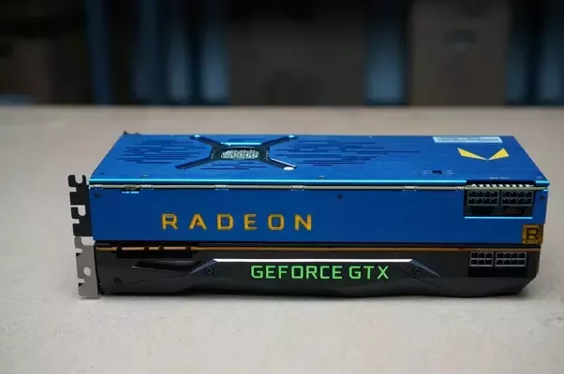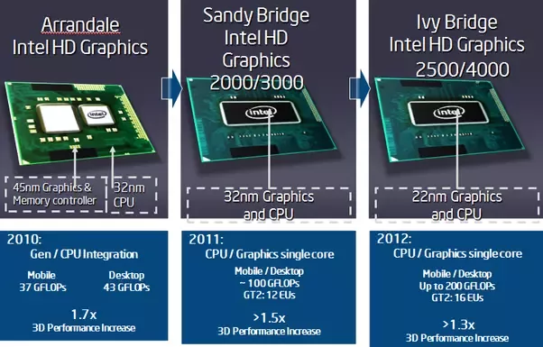

**Fig-9:Integrated graphics fig-10:dedicated graphics**

* A dedicated graphics is more powerful than a shared GPU and it has a dedicated VRAM (in your case 1 GB) to handle all the graphical works. The integrated GPU is powerful, but not powerful enough to render 3D games.
* The shared graphics or the Integrated graphics comes along with your CPU… The CPUs have integrated graphical processing unit to handle light graphical processing works.
* The dedicated GPU (may be nvidia or AMD) has lot of processing power and they are fabricated to serve only one purpose i.e. to handle complex calculations which includes graphical processing too

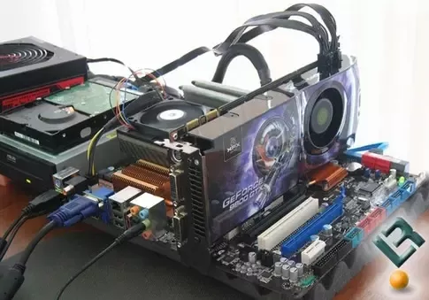

Dedicated graphics

**Fig-11:Dedicated graphics**

 Just as your system has a CPU, some RAM, a CPU fan and a board that connects these components, so does your dedicated graphics card has a board that has a GPU (the equivalent of a CPU), some graphics memory (the equivalent of RAM, known as VRAM), a GPU fan with all of these interconnected on its own board. This board then fits on the larger motherboard through a slot meant for such purposes.

## **14.0 PCI PCIeImage result for pci and pcie slots**

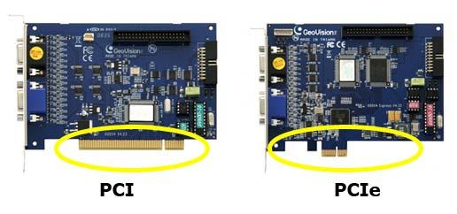

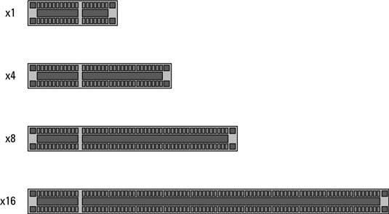

**Fig-12:PCI lanes**

## **14.1 PCIe lanes**

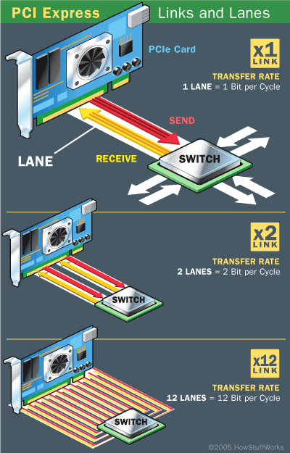

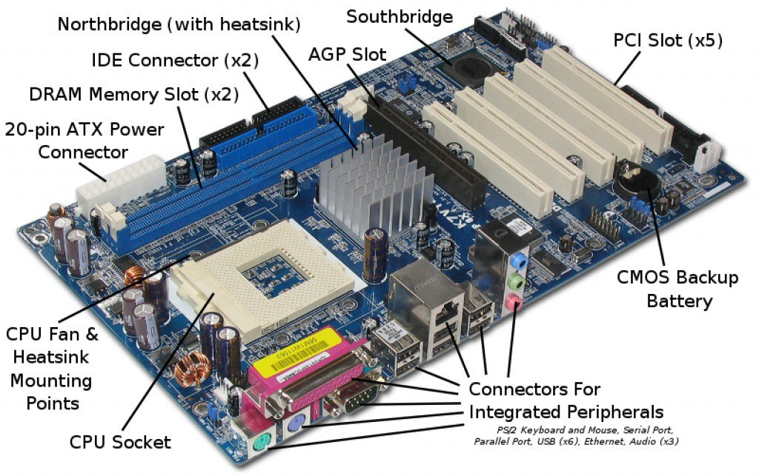

**Fig-13:PCI slots on the motherboard**

## **15.0 monitors**

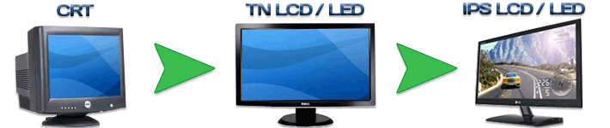

**Cathode Ray Tube  twisted nematic in-plane switching**

## **16.0 Types of printers**

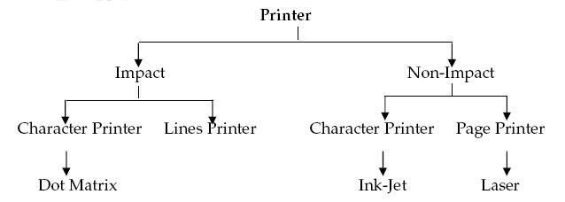

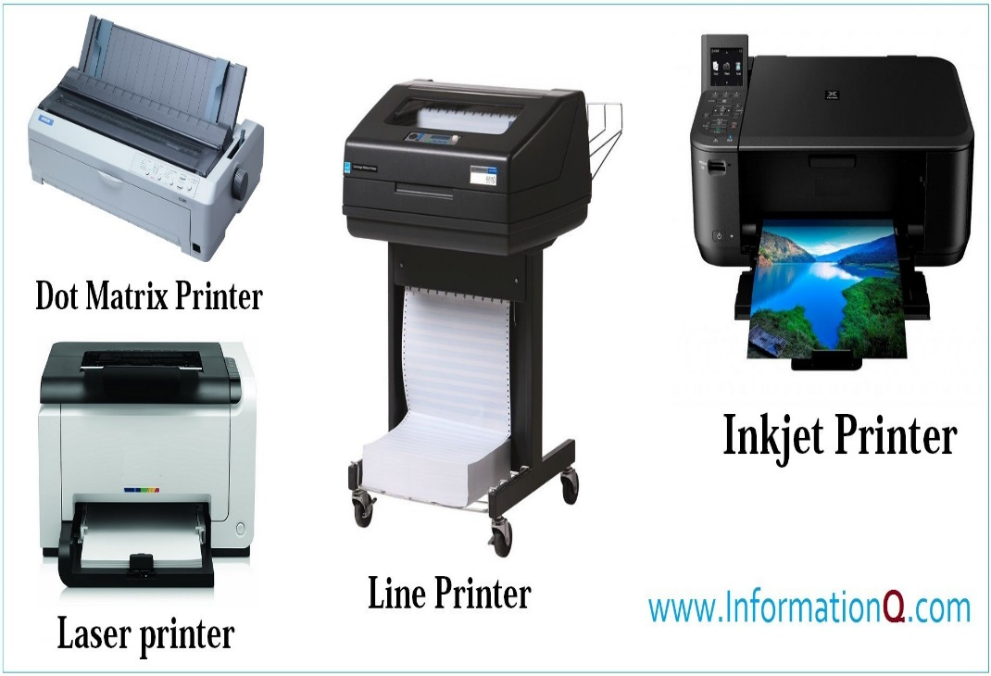

## **Related image17.0 SCSI interface**

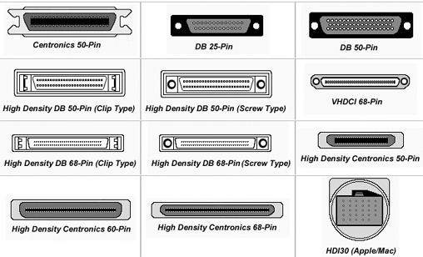

## **18.0 BAR code reader and scanner**

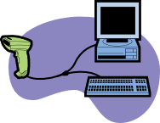 

BAR code reader

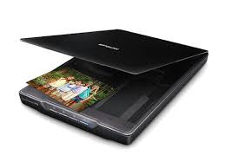

Scanner

## **19.0 Computer Network**

* Computer Network is a system in which multiple computers are connected to each other to share information and resources.

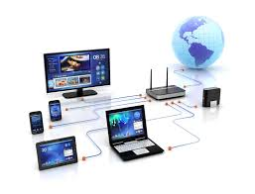

## **19.1 Advantages of Computer Network**

* Better Communication
* File Sharing
* Entertainment
* Flexible Access
* Inexpensive System
* Instant and Multiple Access
* Internet Access
* Resource Sharing

## **19.2 Types of Computer Network**

* Computer networks can be categories by their size as well as their purpose.
* The size of a network can be expressed by the geographic area.
* Some of the different networks based on size are:
  + LAN – Local Area Network
  + MAN – Metropolitan Area Network . WAN – Wide Area Network

## **19.3 LAN**

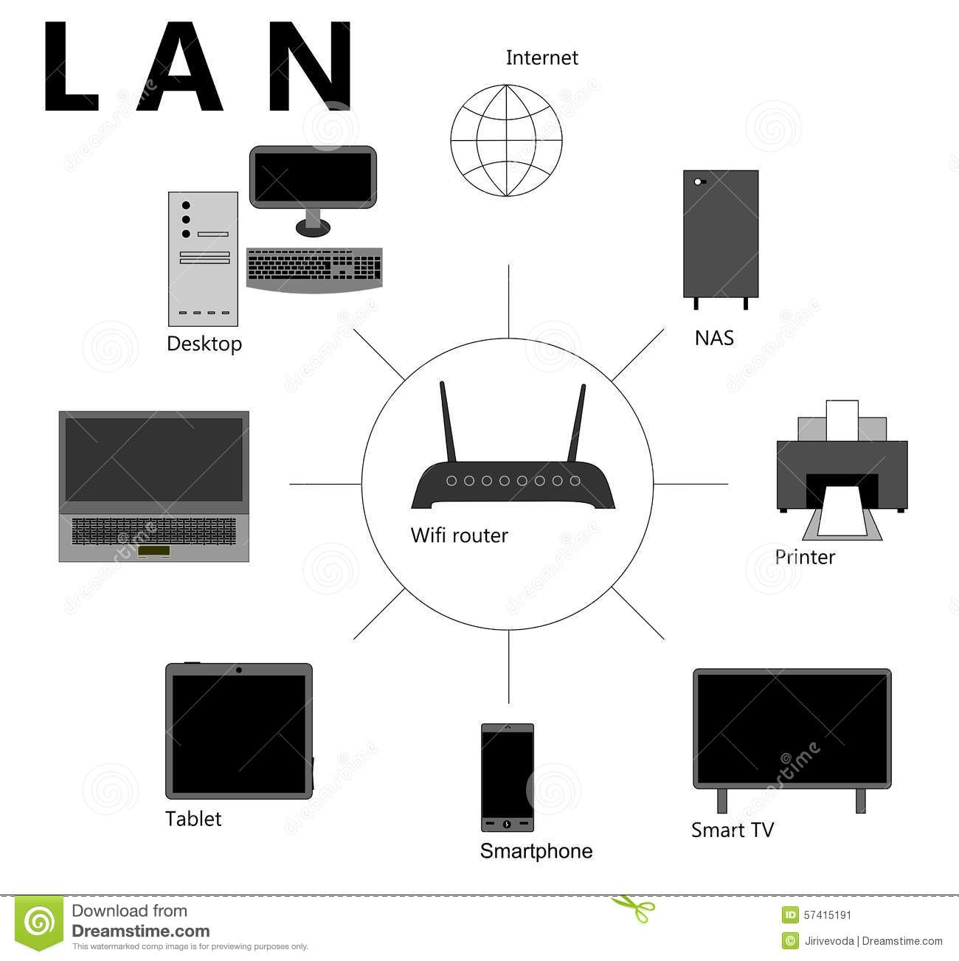

* Group of computers and network
* Communication devices interconnected within a geographically limited area, such as a building or a campus.
* transfer data at high speeds
* Key purpose is to serve its users in resource sharing.
* Hardware and software resources are shared.

## **19.4 MAN**

* Spread over city, for example cable TV networks.
* Purpose is sharing hardware and software resource among it’s users
* MAN is a larger than LAN but smaller than the area covered by a WAN
* It is also used to interconnection of several local area network.

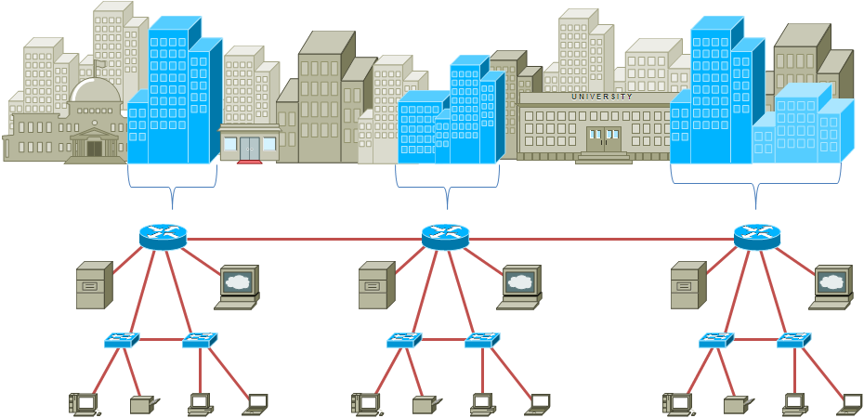

## **19.5 WAN**

* Spread across countries.
* Group of LANs that are spread across several locations and connected together to look like one big LAN.
* Facilitate fast and efficient exchange of information at lesser cost and higher speed.
* The largest WAN in existence is internet.

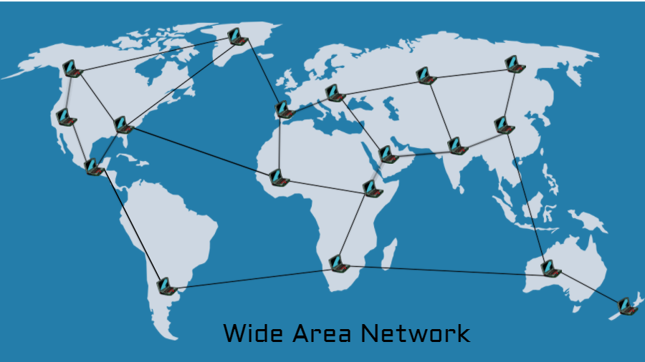

## Types of Computer Network

|  |  |  |  |
| --- | --- | --- | --- |
| Basis Of Comparison | **LAN** | **MAN** | **WAN** |
| Full Name | Local Area Network | Metropolitan Area Network | Wide Area Network |
| Meaning | A network that connects a group of computers in a small geographical area | It covers relatively large region such as cities, towns | It spans large locality & connects countries together. e.g. Internet |
| Ownership of Network | Private | Private or Public | Private or Public (VPN) |
| Design and Maintenance | Easy | Difficult | Difficult |
| Propagation Delay | Short | Moderate | Long |
| Speed | High | Moderate | Low |
| Components used | NIC, Switch, Hub | Modem, Router | m.wave/ Radio Tx & Rx |
| Range(Approximately) | 1 to 10 km | 10 to 100 km | Beyond 100 km |
| Used for | College, School, Hospital | Small towns, City | State, Country, Continent |

## **20.0 Network Topology**

* Network topology is the arrangement of the various elements of a computer or biological network

1. Point-to-Point Link
2. Star Topology Communication Link
3. Bus or Linear Topology
4. Ring or Circular Topology
5. Tree Topology Bus or Liner
6. Graph Topology Mesh (Fully)
7. Mesh Topology

**20.1 Point- to- Point Link**

* Depends on two functions- transmit and receive
* Each station receives exactly from one transmitter
* Each transmitter transmits to exactly one receiver
* Can grow by install a P-P link between each pair of computer in network. This approach is called a Mesh
* Transmit and receive operations can occur either over separate wire or over the same wire

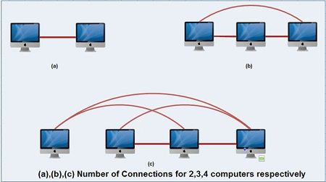

## **20.2 Star Topology**

* Consists of central node to which all other nodes are connected by a single path
* Used in information networks involving data processing or voice communication
* Eg: IBM 370 installations
* Advantages
  + Easy to install and wire
  + No disruptions to the network when connecting or removing devices
  + Easy to detect faults to remove parts
* Disadvantages
  + Require more cable length than a linear topology
  + If the hub, switch, or concentrator fails, nodes attached are disabled
  + More expensive than linear/ bus topologies because of cost of the hubs, etc

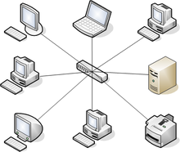

**Fig-14:Star topology**

## **20.3 Linear Bus Topology**

* Consists of single length of the transmission medium on to which the various nodes are attached
* Data is transmitter in small blocks known as packets
* Each packet has some data and destination address
* Transmit some data by send it in packet along with bus
* Destination devices copies the data onto its disk
* Advantages
  + Easy to connect a computer / peripheral to a linear bus
  + Requires less cable length than a star topology
  + Simple architecture
* Disadvantages
  + Entire network shuts down if there is a break in main cable
  + Terminators are required at both ends of the backbone Cable
  + Difficult to identify the problem if the entire network shuts down
  + Not meant to be used as a stand-alone solution in a large building

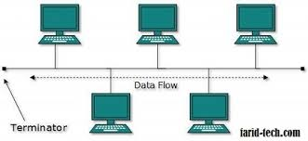

## **20.4 Ring/ Circular Topology**

* Each node is connected to two and only two neighbouring nodes
* Data is accepted from one of the neighbouring nodes and is transmitted onwards to another
* Data travels only in one direction
* Signal may be improved before being used in outward channel
* Advantage
  + Suitable for optical fibre
  + Each computer has equal access to resources
  + Additional components do not affect the performance of network
  + Very organised
  + Requires less cable length than a star topology
* Disadvantages
  + If one node fails to pass data, entire network fails
  + Slower than star topology
  + Difficult to identify the problem in the case of network failure
  + *Reconfiguration of network is difficult*

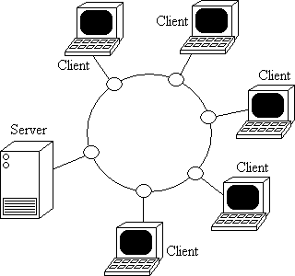

## **20.5 Tree Topology**

* Variation of bus topology
* Shape of the network is like a tree with central branching and sub branching
* Transmission is done in the same way as in bus topology
* Best suited for application which have hierarchical flow of data and control
* Also called hybrid topology
* No need to remove packets from the medium
* Advantages
  + Point- to- Point wiring for individual segments
  + Supported by several hardware and software venders
* Disadvantages
  + Overall length of each segment is limited by the type of cabling used
  + If the backbone line breaks, the entire segment goes down
  + More difficult to configure and wire than other topologies

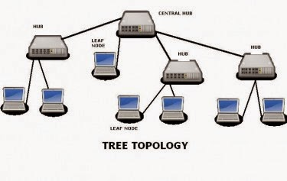

## **20.6 Graph Topology**

* Nodes are connected together randomly
* A link may or may not connect two or more nodes
* There may be multiple nodes
* Not necessary that all the nodes are connected
* If path can be established in two nodes through one or more links, it is known as connected graph

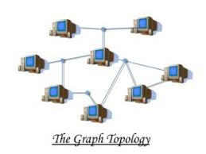

## **20.7 Mesh Topology**

* Each node is connected to more than one node
* Extensions to P-P network
* Outstanding for long distance
* Provide extensive backup, rerouting and pass-through capabilities
* Communication is possible between any two nodes on the network
* Used in large internetworking environments
* Ideal for distributed networks

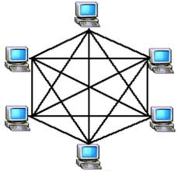

## 21.0 Network Devices

## 21.1 Hubs

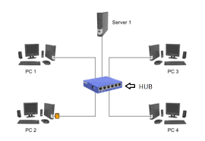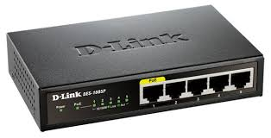

**Fig-14:network Hub**

* Hubs are devices used to link several computers together. They repeat any signal that comes in on one port and copy it to the other ports (a process that is also called broadcasting)
* There are two types of hubs:.
  + **Passive hubs** simply connect all ports together electrically and are usually not powered. (no signal regeneration)
  + **Active hubs** use electronics to amplify and clean up the signal before it is broadcast to the other ports.(provide signal regeneration)
* In the category of active hubs, there is also a class called “intelligent” hubs, which are hubs that can be remotely managed on the network.

## **21.2 Bridges**

* They join similar topologies and are used to divide network segments
* For example, with 200 people on one Ethernet segment, the performance will be mediocre, because of the design of Ethernet and the number of workstations that are fighting to transmit. If you divide the segment into two segments of 100 workstations each, the traffic will be much lower on either side and performance will increase.
* If it is aware of the destination address, it is able to forward packets; otherwise a bridge will forward the packets to all segments. They are more intelligent than repeaters but are unable to move data across multiple networks simultaneously.
* Unlike repeaters, bridges can filter out noise.
* The main disadvantage to bridges is that they can’t connect dissimilar network types or perform intelligent path selection. For that function, you would need a router

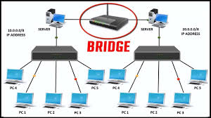

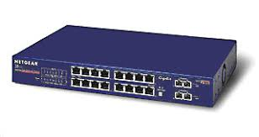

**Fig-15: Network bridge**

## **21.3 Routers**

* Routers are highly intelligent devices that connect multiple network types and determine the best path for sending data.
* The advantage of using a router over a bridge is that routers can determine the best path that data can take to get to its destination.
* Like bridges, they can segment large networks and can filter out noise.
* However, they are slower than bridges because they are more intelligent devices; as such, they analyze every packet, causing packet-forwarding delays. Because of this intelligence, they are also more expensive.
* Routers are normally used to connect one LAN to another. Typically, when a WAN is set up, there will be at least two routers used.
* 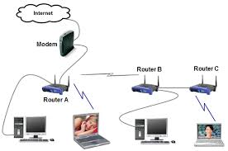Internetwork connectivity device

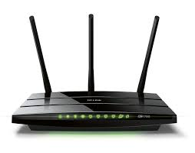

**Fig-16: Router**

## **21.4 Switch**

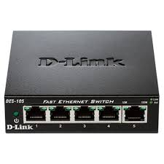

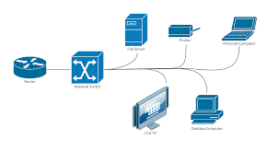

**Fig-17:network switch**

* A network switch is a computer networking device that connects network segments.
* Low-end network switches appear nearly identical to network hubs, but a switch contains more "intelligence" (and a slightly higher price tag) than a network hub.
* Network switches are capable of inspecting data packets as they are received, determining the source and destination device of that packet, and forwarding it appropriately.
* By delivering each message only to the connected device it was intended for, a network switch conserves network bandwidth and offers generally better performance than a hub.
* A vital difference between a hub and a switch is that all the nodes connected to a hub share the bandwidth among themselves, while a device connected to a switch port has the full bandwidth all to itself.
* For example, if 10 nodes are communicating using a hub on a 10-Mbps network, then each node may only get a portion of the 10 Mbps if other nodes on the hub want to communicate as well. But with a switch, each node could possibly communicate at the full 10 Mbps

## **21.5 Gateways**

* A gateway is a network point that acts as an entrance to another network. On the internet, in terms of routing, the network consists of
  + **Host nodes:** computer of network users and the computers that serve contents (such as Web pages).
  + **Gateway nodes:** computers that control traffic within your company’s network or at your local internet service provider (ISP)
* A network gateway is a computer which have internetworking capability of joining together two networks that use different base protocols.
* Gateway is node on network that provide entry to another network.
* Operates at highest layer of network abstraction.
* Perform data translation and protocol conversion.
* Associated with both router and switch.
* Can be implemented on software, hardware, or as a combination of both.
* The key point about a gateway is that only the data format is translated, not the data

## **Image result for network gateway21.6 Repeater**

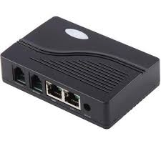

**Fig-18:Repeater**

* It is a device that amplifies and restores the power of a signal being transmitted on the network.
* Can be installed along the way to ensure that data packets reach their destination.
* Used in long network lines.
* Two types of Repeaters:
  + **Amplifier** : amplifies the incoming signals over the network.
  + **Signal repeater** : collects the inbound packet and retransmits them.

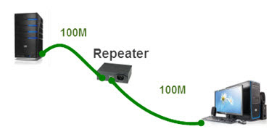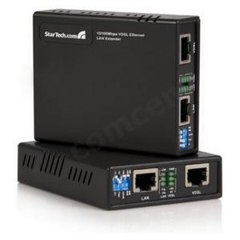

**Fig-18:Repeater**

## **22.0 Network Media**

* Signals between computers in a network carried through cable based media or wireless media
* Generally 3 types of cables are used
  + Twisted pair cable
    - Unshielded twisted pair (UTP)
    - Shielded twisted pair (STP)
  + Coaxial cable
  + Fibre-optic cable

## **22.1 Unshielded twisted pair (UTP)**

* is a set of three or four pairs of wires with each wire in each pair twisted around the other to prevent electromagnetic interference.
* UTP cabling uses RJ-45, RJ-11, RS232, and RS-449 connectors.
* Because it is less expensive and easier to install, UTP is more popular than Shielded Twisted Pair (STP) or Coaxial Cabling.
* An example of UTP application is telephone networks, which use RJ-11 connectors, and 10BASE-T networks, which use RJ-45 connectors.
* UTP comes in the form of Cat 2, 3, 4, and 5 grades; however, only Cat 5 is now recommended for any data applications.
* The maximum length is 100 meters, without using any kind of signal regeneration device, and a maximum data transfer rate of 1000 Mbps for Gigabit Ethernet.

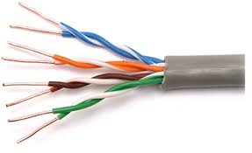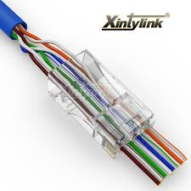

## **22.2 Shielded Twisted Pair (STP)**

* Shielded Twisted Pair (STP), like UTP, also has four pairs of wires with each wire in each pair twisted together.
* However, STP is surrounded with a foil shield and copper braided around the wires that allows more protection from any external electromagnetic interference.
* Because of the shielding, the cable is physically larger, more difficult to install and terminate, and more expensive than UTP.
* For applications in electrically noisy environments, STP uses RJ-45, RJ-11, RS-232, and RS-449 connectors.
* Like UTP, STP also comes in Cat 2, 3, 4, or 5 grades; however, only Cat5 is recommended for any data applications.
* The maximum cable length with no signal regenerating device is 100 meters, with a maximum data transfer rate is 500 Mbps.

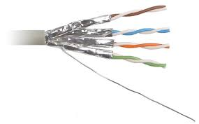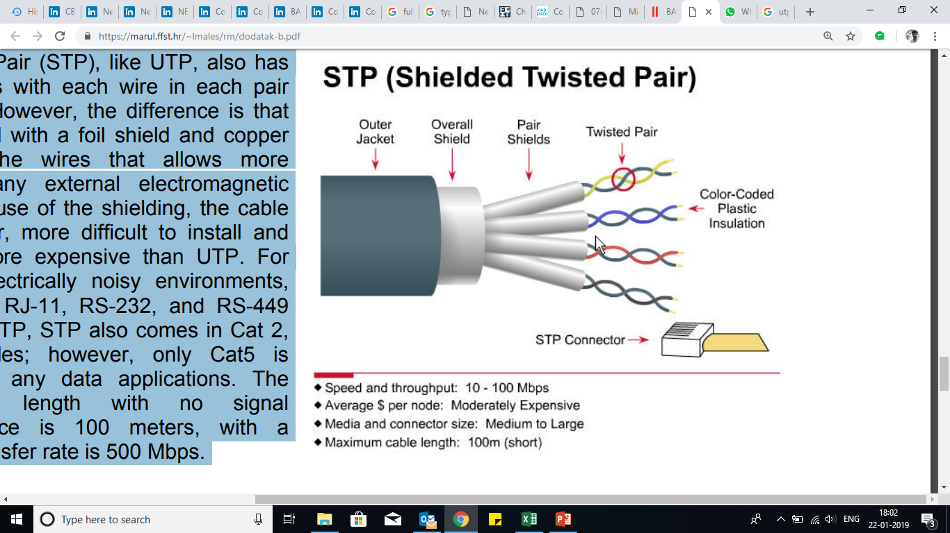

### **22.3 STP v/s UTP**

* STP cables are shielded while UTP cables are unshielded
* STP cables are more immune to interference and noise than UTP cables
* STP cables are better at maximizing bandwidth compared to UTP cables
* STP cables cost more per meter compared to UTP cables
* STP cables are heavier per meter compared to UTP cables
* UTP cables are more prevalent in SOHO networks while STP is used in more high-end applications

## **22.4 Coaxial cable**

* Coaxial cable is braided-grounded strands of wire that can provide some shielding and noise immunity;
* however, the installation and the termination of the cable itself can be costly.
* Coaxial cabling, which uses connectors called BNC (Bayonet Nut Connector) is known as, in forms of Ethernet, thicknet and thinnet, in the older LAN technology, ARCnet, and cable TV.

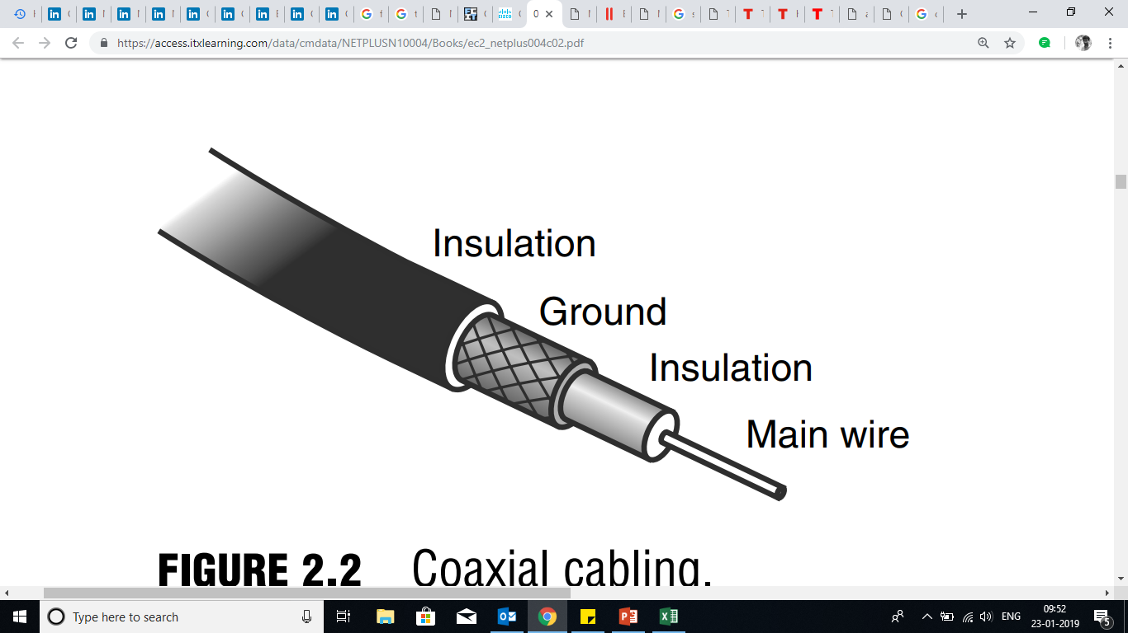

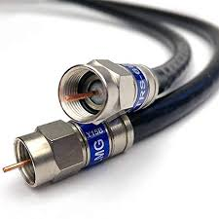

## **22.5 Fibre-optic cable**

* Fiber optic cabling carries signals, which have been converted from electrical to optical (pulses of light) form.
* It consists of the core, either an extremely thin cylinder of glass or optical quality plastic, which is surrounded by a second glass or plastic layer called the cladding.
* The interface between the core and cladding can trap light signals by a process called Total Internal Reflection (TIR), resulting in the optical fiber acting as a light pipe.
* Protective buffer and jackets materials are used to cover the cladding layer.
* This type of cabling is less frequently used because it is somewhat more expensive; however, it is rapidly decreasing in both raw cost and installed cost.
* Fiber optic cables are not susceptible to interference, such as radio waves, fluorescent lighting, or any other source of electrical noise.
* It is the common cable used for network backbones and can support up to 1000 stations, carrying signals beyond 25 km.

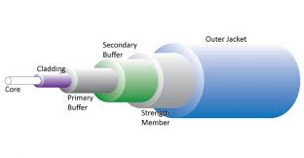

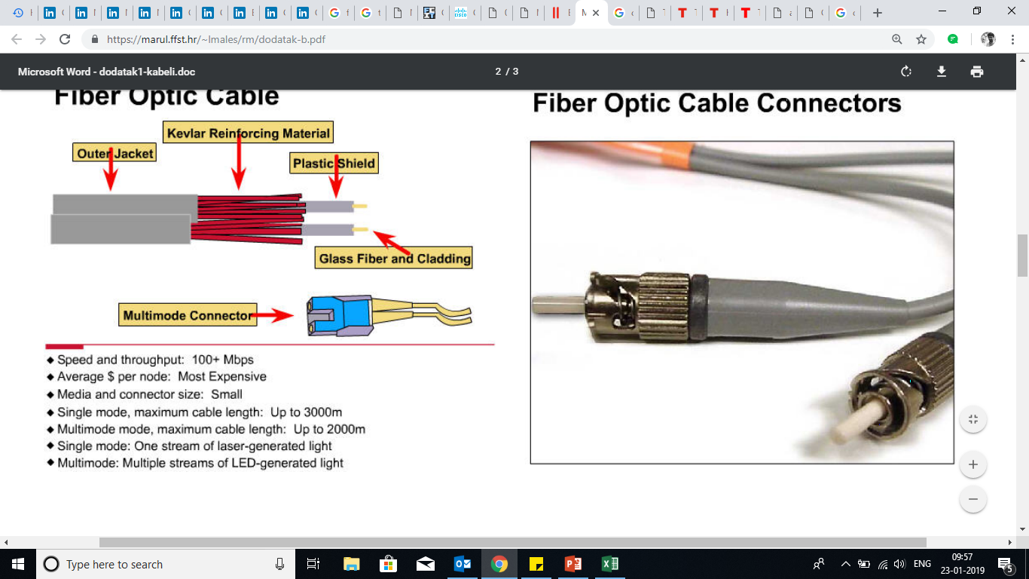

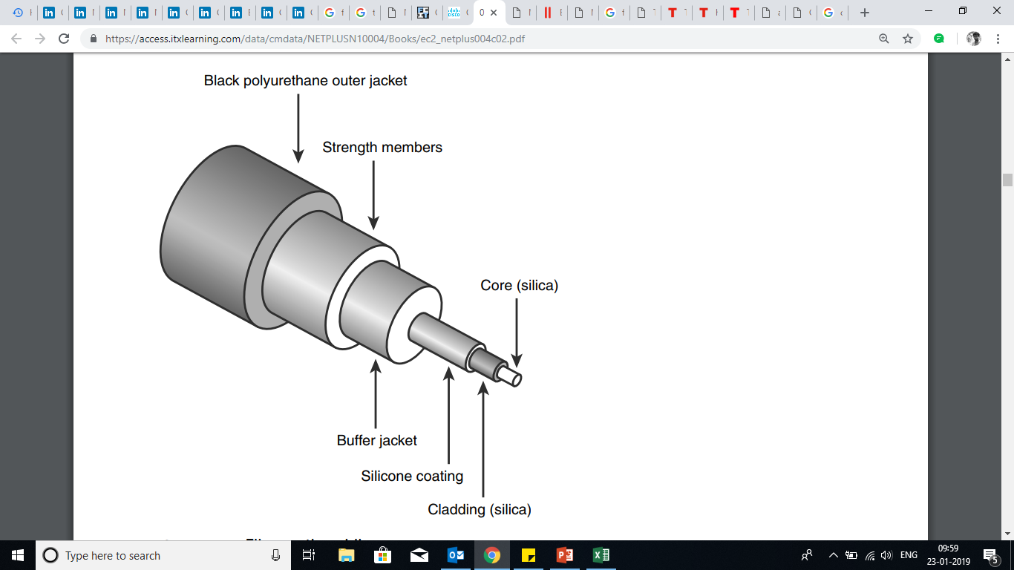

## **23.0 Wi-Fi standards**

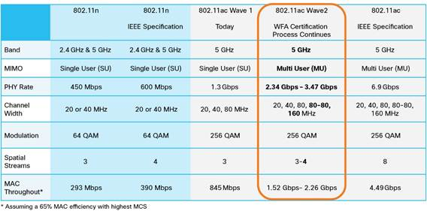

## **Linksys LAPAC1200 Business AC1200 Dual-Band Access Point - Image23.1 Access Point (AP)**

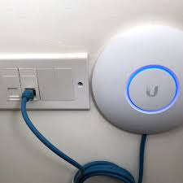

**Fig-19:network access Point**

* Access Point is a wireless LAN transceiver or “base station” that can connect one or many wireless devices simultaneously to the Internet.
* An access point is a device that creates a wireless local area network, or WLAN, usually in an office or large building.
* An access point connects to a wired router, switch, or hub via an Ethernet cable, and projects a Wi-Fi signal to a designated area.
* For example, if you want to enable Wi-Fi access in your company's reception area but don’t have a router within range, you can install an access point near the front desk and run an Ethernet cable through the ceiling back to the server room.

## **Image result for pci wifi card23.2 wireless card**

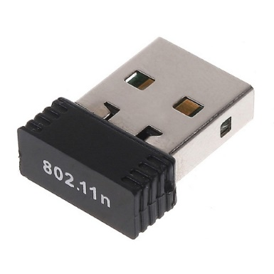

* Wi-Fi cards - They accept the wireless signal and relay information. They can be internal and external.(e.g PCMCIA Card for Laptop and PCI Card for Desktop PC)

## **23.3 Print server**

* A print server is a device that allows you to share a printer with multiple computers.
* It may be a standalone adapter or may be integrated within a printer or a router.
* When activated, the print server allows a printer to connect to a local network rather than a single computer, which then can be accessed by multiple devices
* Standalone print servers come in several varieties. Most have a USB port, which connects directly to the USB port of the printer. However, some print servers can connect to a printer's Ethernet or parallel port as well.
* Wired print servers include an Ethernet port for connecting directly to a router, while wireless versions are able to connect to a Wi-Fi network.
* Printers that include a built-in print server are often called "network printers" or "wireless printers
* Some routers can also function as print servers. Besides the typical Ethernet ports, they also include a USB port for connecting a printer.

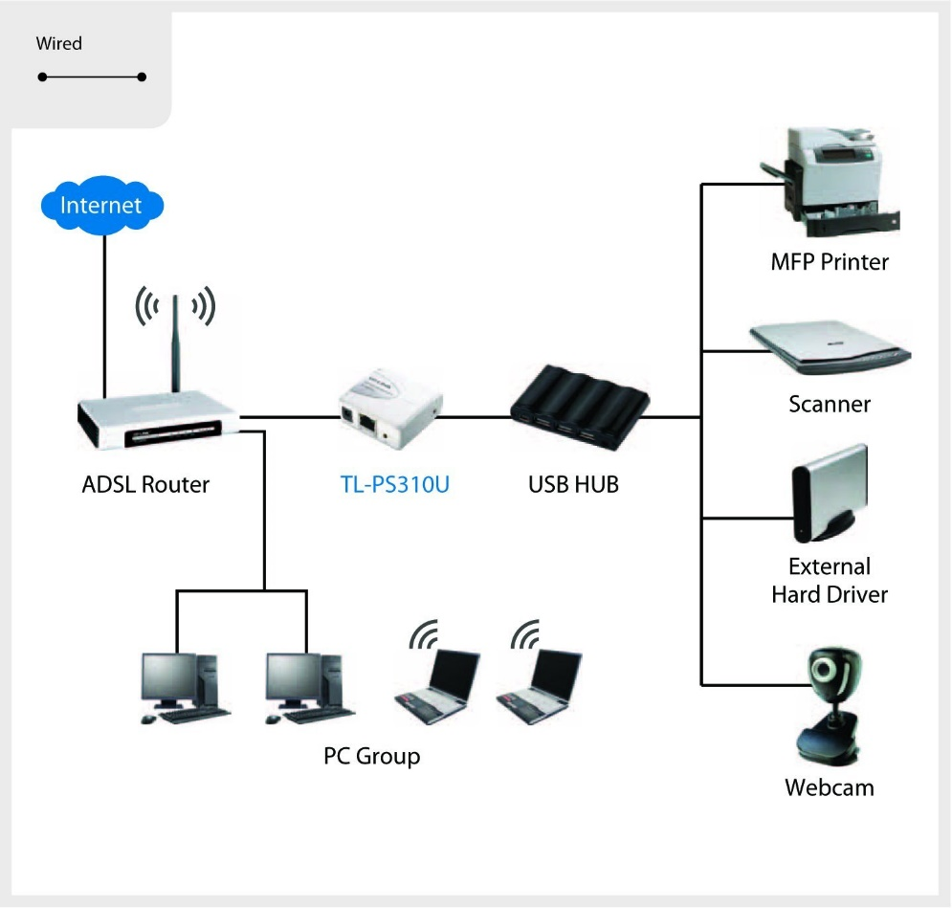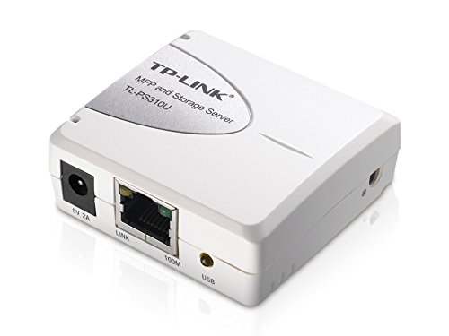

**Fig-20:Print server**